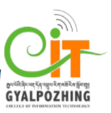

**Proposal**

**For**

**Second Year Mini Project**

**Bachelor of Science in Information Technology**

**GK Quiz**

**Submitted by**

**Phurpa Thinley(12190071)**

**Gyalpozhing College of Information Technology**

**Read carefully before filling the form.**

1. Please do not alter the layout of the application form. Information must be filled in the spaces provided, under set format.
2. Guidance notes in various fields should not be deleted.
3. Required information should be duly filled in the specified fields.
4. Required heads/fields which are not relevant to the project should be marked **N/A** (Not Applicable) or left blank and should not be deleted.

**Guidelines and Forms**

**Submission Procedure**

Duly filled proposal forms completed in all respects should be submitted in form of soft copy and a hard copy to project guide and project coordinator. On receipt of the applications the proposals will be evaluated by reviewer panel and proposal would then be defended by student groups. The project group may need to revise the proposal in light of the evaluator’s recommendations.

**For further information, please contact:**

Project Coordinator

Jigme Wangmo

[jigmewangmo.gcit@rub.edu.bt](mailto:jigmewangmo.gcit@rub.edu.bt)

Tshering Lhamo

[tsheringlhamo.gcit@rub.edu.bt](mailto:tsheringlhamo.gcit@rub.edu.bt)

**Table of Contents**

Description Page #

1. Project Identification 1

2. Scope, Introduction and Background of the Project 3

3. Aim and Objectives of the Project 5

4. Methodology 6

5. Benefits of the Project (Expected output/outcomes): 10

6. Risk Analysis/Feasibility 10

7. Project Approval Certificate 11

8. Reviewers Panel Comments 13

10. Project Schedule / Milestone Chart /Work plan 14

13. Report Writing Guidelines 15

Bibliography 16

**Note:** To update the table of contents, right click in the table and select ‘*update field*’ and then select ‘Update Entire Table’.

**Application for Final Year Project**

# 1. Project Identification

|  |  |  |  |
| --- | --- | --- | --- |
| 1. Reference Number: | | | |
| (for office use only) | | | |
| 1. Project Title: GK Quiz | | | |
|  | | | |
| 1. Project Internal Guide: | | | |
| Name: |  | | |
| Designation: |  | | |
| Organization: |  | | |
| Mobile # : |  | Tel. # : |  |
| Email: |  | | |
| **C1. Project External Guide:** | | | |
| Name: | **NA** | | |
| Designation: |  | | |
| Organization: |  | | |
| Mobile # : |  | Tel. # : |  |
| Email: |  | | |
| **C2. Student Group Lead:** | | | |
| Name: |  | | |
| Roll No: |  | | |
| Department: |  | | |
| Mobile # : |  | Tel. # : |  |
| Email: |  | | |

|  |  |  |  |
| --- | --- | --- | --- |
| 1. Organizations Involved in the Project:   *(Please identify all affiliated organizations collaborating in the project, and describe their role/contribution to the project.)* | | | |
| **D1. Industrial Organizations:** | | | |
| *#* | *Organization Name* | | *Role / Contribution* |
|  | *NA* | |  |
| **D2. Academic Organizations:** | | | |
| *#* | *Organization Name* | *Role / Contribution* | |
|  |  |  | |
| **D3. Funding Organizations:** | | | |
| *#* | *Organization Name* | | *Role / Contribution* |
|  | *NA* | |  |
| 1. Key Words:   *(Please provide a maximum of 5 key words that describe the project. The key words will be incorporated in our database.)* | | | |
| Online, specific digital platform,open education resources, interactive application | | | |
| 1. Research and Development Theme:   Develop a platform to provide necessary materials for students to learn easily as well as to catch materials within a short span. There are lots of students who are willing to know the knowledge of Bhutan but they did not have convenient source. The General knowledge quiz application will help the student’s to access the authentic information or question regarding the cases which are really in need of learning purpose. As of now in Bhutan there is no such application like GK quiz for improvement of there General Knowledge. Therefore, I was strongly motivated to come up with such idea where they have to sign up for registration in order to attempt quiz and get immediate feedback. | | | |
|  | | | |
| 1. Project Status:   (Please mark ☑)  q New ☑ Modification to previous Project  ☑ Extension of existing project | | | |

|  |  |  |
| --- | --- | --- |
| 1. Project Duration: | | |
| Expected Starting Date: | 14/02/2021 | |
| Planned Duration in months: | 6 months | |
|  |  |  |

# 2. Scope, Introduction and Background of the Project

|  |
| --- |
| 1. Scope of the Project: |
| System scope(features)   * **Attempt:** allow users to attempt quiz. * **Sign up:** In order to discuss on the questions, user needs to complete the registration process (Name, Email, and Phone Number, password). * **Submit:** Allow the users to submit their answers. * **Update:** The questions of the general knowledge will be update by the admin. * **Retry :** allow user retry the quiz after completing. * **Next:** if user willing to attempt another type of question they can enter into next. * **Result:** it allows user to view the score mark.   **User Scope (Target and area coverage)**  The Scope of the project Is limited within our country. Since all the general knowledge quizzes question will be within our country, in future quizzes question will expanding scope to globally. |

|  |
| --- |
| 1. Introduction (Project Background and Literature Review, Current State of the Art):   *(Detailed summary of what all has been done internationally in the proposed area quoting references and bibliography. Please note that this section demonstrates the depth of knowledge of the project team and builds the confidence of the evaluators about capability of the team in achieving the stated objectives.)*  *(Please describe the current state of the art specific to this research topic.)*  Higher education is changing. Most if not all students now have access to learning materials via the Internet. Students expect and need different things from their instructors. They need to be guided through their learning process. They expect the instructor to teach them how to build their knowledge and comprehension of the given subject. Furthermore, they expect them to use technology to do this. Instructors must meet this challenge and integrate technology into their courses, effectively facilitating the students' learning process. The instructors must therefore be confident that the investment is worthwhile – that the effective use of new tools leads to better outcomes, in both students' attitudes and in their professional understanding.  According to Trow (1999), studies are needed to assist teaching staffs in high schools, colleges and universities to recognize the possibilities of using technology as an effective tool in the teaching process and to enhance the positive outcomes that it may bring about.  The use of online quizzes would allow the instructor to engage students in more active learning, group projects, and class discussion. It also was expected that the online quizzes, coupled with immediate feedback regarding the percentage of correct answers given, would be viewed positively by students as an effective means of learning the course material.  Aim of this project to create a platform consisting general knowledge quiz question of our country. If the users want to attempt the quiz they have to sign up and filled the page for security purposes. Without signing they wont be able to attempt the quiz. Quizzes encourage students to study regularly without wasting time where they can build general knowledge of Bhutan gradually. Quiz helps in long-term retention and keeps student mind sharp. The immediate feedback encourages the students to reflect on their understanding, to implement whatever methods are needed to gain more understanding, and to make another attempt to ascertain whether they have actually improved their knowledge.  **Literature Review:**  According to Merkt et(2011) he have highlighted that quiz questions increase engagement and motivation of learners to want to learn. And also reported the use of a quiz question allows the learners to receive immediate feedback while doing quiz, which in turn frees up time for more focused face to face teaching sessions.  The learning environment should also include innovative technologies that can be used to achieve educational goals and improve the quality of the learning processes (Bransford, Brown & Cocking, 2000).  has highlighted that quiz questions increase engagement and  **Current State of Art:**  In the present situation in Bhutan there is a website where user can attempt quiz but in the developing and advance world many people prefer application than website. As a human peoples are tends to be lazy and searching from websites are just consuming time for this easy accessibility of learning purposes general knowledge quiz will helps to get attach with study and build there own knowledge.  A well-designed mobile app can perform actions much quicker than a mobile website. The reason apps are better than website are that Apps usually store their data locally on mobile devices, in contrast to websites that generally use web servers. For this reason, data retrieval happens swiftly in mobile apps. Apps usually store their data locally on mobile devices, in contrast to websites that generally use web servers. For this reason, data retrieval happens swiftly in mobile apps. One of the main distinctions between mobile web and apps is the ability of the latter to work offline. |

|  |
| --- |
| 1. Challenges:   *(Please describe the challenges, specific to this research topic, currently being faced internationally.)*  **Completing the task as per the schedule:** Time needs to be spend on learning android development, on research, content part of the app (what needs to be included) and for developing the app.  We can‟t assure the probability of completing the project as per the schedule. |
|  |
| 1. Motivation and Need:   *(Please describe the motivation and need for this work.)*  Till date there has not been any mobile app which provides general knowledge quiz facility in our country hence, I am introducing “GK Quiz” to help the students to build knowledge of our country for the long-term retention and helps students to encourage study regularly hence they can make themselves mind sharp.  Although there are existing websites where they can do a quiz but the process of searching the websites for quiz is usually tiring and time consuming process which does not always prove to be efficient. So if such an app is developed, there will be easy access to the general knowledge quiz of Bhutan. |
|  |

# 3. Aim and Objectives of the Project

|  |
| --- |
| *(Please write the actual aim of your project. Also, describe the measurable objectives of the project and define the expected results. Use results-oriented wording with verbs such as ‘to develop..’, ‘to implement..’, ‘to research..’, ‘to determine..‘, ‘to identify..’ The objectives should not be statements and should not include explanations and benefits. The objective should actually specify in simple words what the project team intends to achieve (something concrete and measurable/ deliverable). Fill only those objectives that are applicable to the proposed project.)* |
| AIM :  To develop an android application for attempt quiz of general knowledge of Bhutan.  OBJECTIVES :  The objective of project are:  1. To promote study skills and to regularly touch with their study.  2. It will help the students to build or improve one’s general knowledge. |
|  |
|  |

# 4. Methodology

|  |
| --- |
| 1. Development / Research / Test Methodology:   *(Please describe the technical details and justification of your development and research plan and test plan and testing strategies. Identify specialized equipment, facilities and infrastructure which are required for the project and their utilization plan. The block diagrams, system flow charts, high level algorithm details etc. have to be provided in this section. Also, describe the overall methodology to be used for the particular research topic)*  General Methodology  Following are the software process that will be involved in developing the project:  **>Problem statement**  The web application and guide book that exist in Bhutan which was used by learners is not efficient and effective method as that of mobile/online application since learners have to search in website and have to read the guide book for gaining knowledge of Bhutan and it takes lot of time to search .Therefore, in order to deal with these problems, the mobile application “GK Quiz” will focus on the reduction of time and effort on build knowledge.  **>Literature review**  The comprehensive summary of previous research paper on related topic is thoroughly discussed in this phase. It includes articles, books and other sources relevant to particular topic.  **>Requirement gathering and analysis**  When collection of all relevant information from research papers and existing system related to stated problems are completed, the team then works on understanding the detailed problem. It involves conducting several for brain storming and survey related to the topic. The SRS document is prepared simultaneously which will serve the purpose of input for design phase. This also helps to provide additional creative ideas and information while designing.  **>Design**  In this phase the design is prepared from the requirement specification which is studied in the first phase. It helps specify hardware and requirements of the system.  **>Implementation**  After successful system design the project is divided into modules and actual coding is started. This is the longest phase software development life cycle.  **>Testing**  After coding, it is tested to make sure that the product is actually serving the needs addressed and gathered during the requirement phase. It makes sure that the system functions as specified and eliminates any issues and errors in this phase.  **>Documentation**  Finally, after completing all the coding and fulfilling all the features of the application, project document is created. |
| Agile SDLC model is a combination of iterative and incremental process models with focus on  process adaptability and customer satisfaction by rapid delivery of working software product. An  Agile model development begins by specifying and implementing just part of the software, which is then reviewed to identify further requirements. This process is then repeated, producing a new version of the software at the end of each iteration of the model.  **Reason for choosing the Agile model for our project are:**  •   * Functionality can be developed rapidly demonstrated. * The speed to change is high as they are iterative in nature and adapts to the changing requirements. * it in inexpensive while meeting the changing requirements as the working software is frequently delivered to the user. * This model draws the inference that the needs of the end user do not remain the same so it require limited planning to begin the process of the project. * Availability of risk identification factor. * Gives flexibility to developers. * High customer satisfaction. * Good models for environments that change steadily.   **PROTOTYPE of Application:**    first view second view third view      fourth view fifth view |

|  |  |
| --- | --- |
| 1. Project Team: | |
| ***Title / Position*** | ***Number*** |
| Project Internal Guide |  |
| Project External Guide |  |
| Student Team Members |  |
| Others (please specify) |  |
| Add more rows if required |  |

|  |
| --- |
| 1. Project Activities:   *(Please list and describe the main project activities, including those associated with the transfer of the research results to customers/beneficiaries. The timing and duration of research activities are to be shown in the Gantt chart in Section 8.)*  **Installation of software and tools:** Installing android studio version (2 and above), Java Development Kit (v8 or more) and database server. Resource gathering: Referring books, video tutorials, online reference related to android app development, Java programming language, MySQL and XML.  **Design Phase:** it includes designing user interface, database design and includes Understanding the functionalities, flow of information, keeping the design concepts in mind.  **Development of the product:** The development of app begins here with coding, using Android.  **Testing the product:** The product will undergo unit test to ensure that each unit functions properly and will also carry out integration testing to ensure that it produce a desired function after combining all the units.  **Final Documentation:** After all the phases are done we will prepare the documentation of the project, project report and at the last we will end with final project presentation. |
|  |

|  |  |  |  |
| --- | --- | --- | --- |
| 1. Key Milestones and Deliverables:   *(Please list and describe the principal milestones and associated deliverables of the project. A key milestone is reached when a significant phase in the project is concluded, e.g. selection and simulation of algorithms, completion of architectural design and design documents, commissioning of equipment, completion of test, etc.) The timing of milestones is also to be shown in the Gantt chart in Section 8.* | | | |
|  | | | |
| *No.* | *Elapsed time from start (in months) of the project* | *Milestone* | *Deliverables* |
|  | *-* | *Commencement of the project* |  |
|  | 02/14/2021-  03/11/2021 | Topic selection | Topic selected |
|  | 03/3/2021-03/14/2021 | Proposal report | Project proposal report |
|  | 03/15/2021-03/21/2021 | Requirement gathering and specification |  |
|  | 03/29/2021-03/31/2021 | Design UI | User interface |
|  | 04/01/2021-04/15/2021 | Feature development: user registration | Feature development |
|  | 04/16/2021-04/30/2021 | Feature development: attempt quiz | Feature development |
|  | 05/01/2021-05/06/2021 | Feature development : score marks of detail | Feature development |
|  | 05/07/2021-05/12/2021 | Feature development : retry quiz and attempt next | Feature development |
|  | 05/13/2021-05/15/2021 | Final testing | Bug free application |
|  | 05/16/2021-05/22/2021 | documentation | Final project documentation. |
|  | 05/23/2021-05/27/2021 | Project report writing | Final report |
|  |  |  |  |
| (Please add more rows if required.) | | | |

# 5. Benefits of the Project (Expected output/outcomes):

|  |
| --- |
| **Following are the benefits or the output obtained from our application:**   * General knowledge quiz question will be accessibility by every user. * Can help students to improve learning skills. * Encourage students to regularly touch with study. * Helps in improving general knowledge of Bhutan.   • |
|  |
|  |

# 6. Risk Analysis/Feasibility

|  |
| --- |
| 1. Risks of the Project:   (Please describe the factors that may cause delays in, or prevent implementation of, the project as proposed above; estimate the degree of risk.)  (Please mark ☑ where applicable) Low Medium High  Technical risk  Timing risk  Budget risk |
| A1. Comments(Describe the risk):  **Technical risk:** Since all the technologies and facilities needed, so will have low technical risk in this project.  **Timing risk:** Time needs to be spend on learning android development, on research, content part of the app (what needs to be included) and for developing the app.  So it can‟t assure the probability of completing the project as per the schedule.  **Budget risk:** since it don‟t have budget risk because for development it don’t have to buy any software or technology. These project can be done using free software available on internet. |
|  |
|  |

# 7. Project Approval Certificate

|  |
| --- |
| *(Approval of Project Proposal by the Competent Authority (Department Chairman) and Project Review Team is mandatory before the start of project execution****.****)*  ***Project Review Team:***  Sl # Name Signature                  (Please add more rows if required.)  ***Project Coordinator***  Name:  Designation:  Email:  Date: Signature:  ***Competent Authority – Head of Department***  Name:  Designation:  Email:  Date: Signature  & stamp: |

# 8. Reviewers Panel Comments

# 10. Project Schedule / Milestone Chart /Work plan

*(Project schedule using MS-Project (or similar tools) with all tasks, deliverables, milestones, clearly indicated are preferred. Task should be measured in terms of hours)*

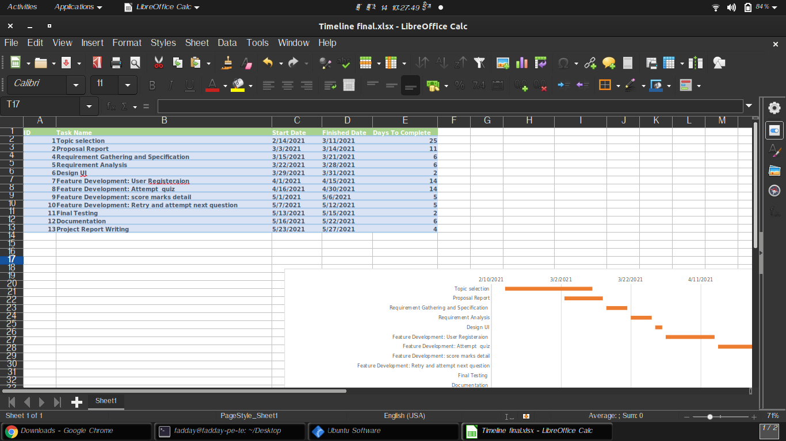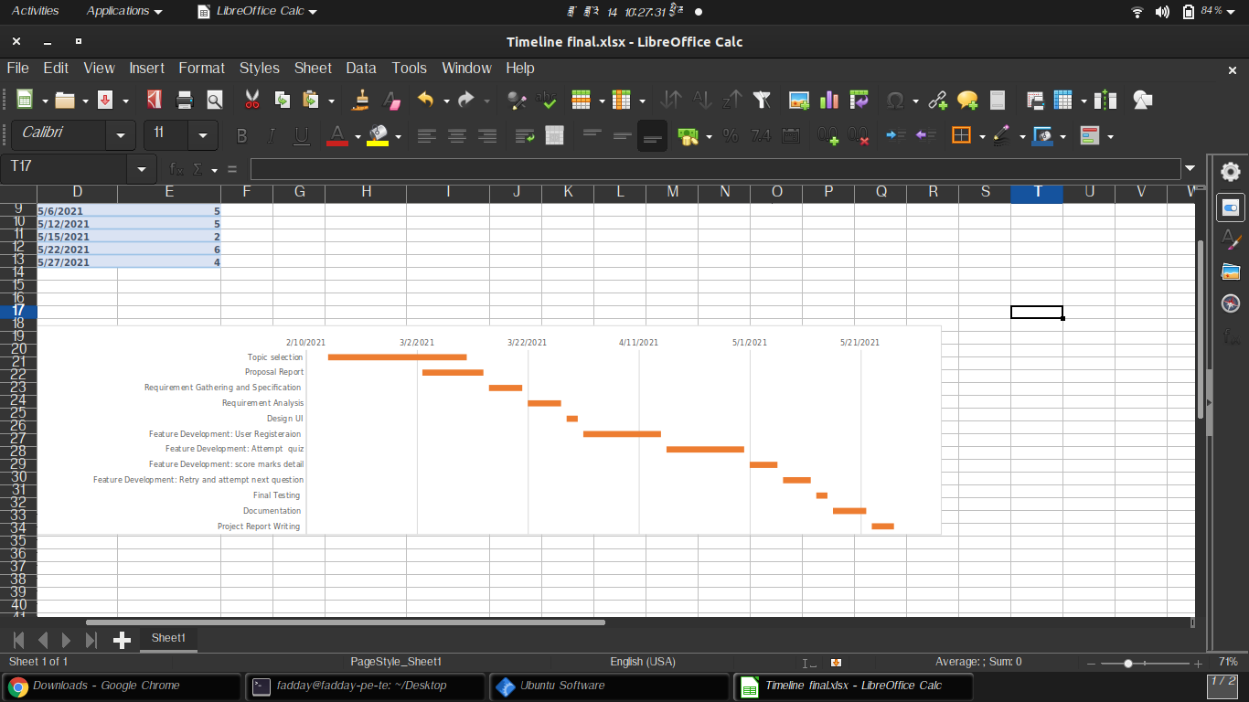

# 13. Report Writing Guidelines

*(Project report will be written under the specified guidelines.)*

# Bibliography

Bransford, J.D., Brown, A.L., & Cocking, R.R. (2000). *How People Learn.* Washington, DC:

National Academy Press.

Brown, J.S. (2006). New learning environments for the 21st century: Exploring the edge *Change: The Magazine of Higher Learning,* 38(5)

Martin-Blas, T., & Serrano-Fernandez, A. (2009). The role of new technologies in the learning

process: *Computers & Education,*